**ELECTRICITY BILLING**

**EXP NO:** 1 - A

**DATE:** 29-11-2022

**AIM:**

To draw flowchart and algorithm for the following program

**ALGORITHM:**

Step 1: start

Step 2: read number of units consumed as N

Step 3: check condition if n<=100

3.1: if condition is true, display no current charge

Step 4: check condition if n<=200

4.1: if condition is true, for 100 units no charge and to calculate energy charge for remaining units then use the formula 1.5*(N-100)

Step 5: check condition if n<=500

5.1: if condition is true, for 100 units no charge and to calculate the energy charge for 101-500 units, then use the formula

Step 6: check condition if n>500

6.1: if condition is true, for 100 units no charge

6.2: For unit 101-200 units, energy charge = 100*3.5 = 350

6.3: For unit 201-500 units, energy charge = 300*4.6 = 1,380

6.4: For remaining units calculate energy charge 2 for remaining units will be (N-500)*6.6

Step 7: total energy charge is calculated by adding

Step 8: print current bill

Step 9: stop

**FLOWCHART:**

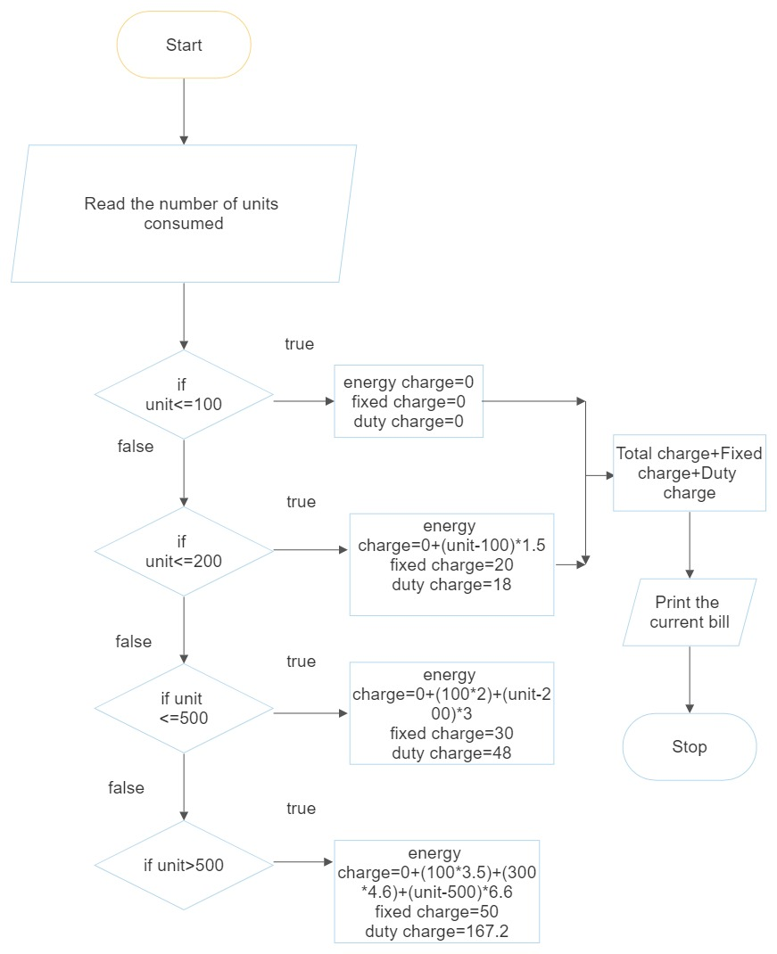

**PSEUDOCODE:**

**START**

**READ** N

**IF** N<=100 **THEN**

**PRINT** “NO CHARGE”

**IF** N<=200 **THEN**

Energy = (N-100)*1.5

FC = 20, DC=18

Total=Energy + FC + DC

**PRINT** Total

**IF** N<=500 **THEN:**

E1=100*2

E2 = (N-200)*3

Energy=E1+E2

FC=30, DC=48

Total=Energy + FC + DC

**PRINT** Total

**IF** N>500 **THEN:**

E1=100*3.5

E2=300*4.6

E2= (N-500)*6.6

Energy=E1+E2

FC**=**50, DC=167.2

Total=Energy + FC + DC

**PRINT** Total

**STOP**

**RESULT:**

Thus the algorithm and flowchart is written for the given program

22CSEB07

**WEIGHT OF IRON ROD**

**EXP NO:** 1 - B

**DATE:** 29-11-2022

**AIM**:

To draw the flowchart and write the algorithm for the given program

**ALGORITHM:**

Step 1: start

Step 2: read the diameter D and length of the iron rod L

Step 3: initialize I = 0 and total = 0

Step 4: check if the value I is less than n

4.1: if the condition is true

4.1.1: calculate the weight of iron rod

4.2: if the condition is false

4.2.1: print the weight of the iron rod

Step 5: stop

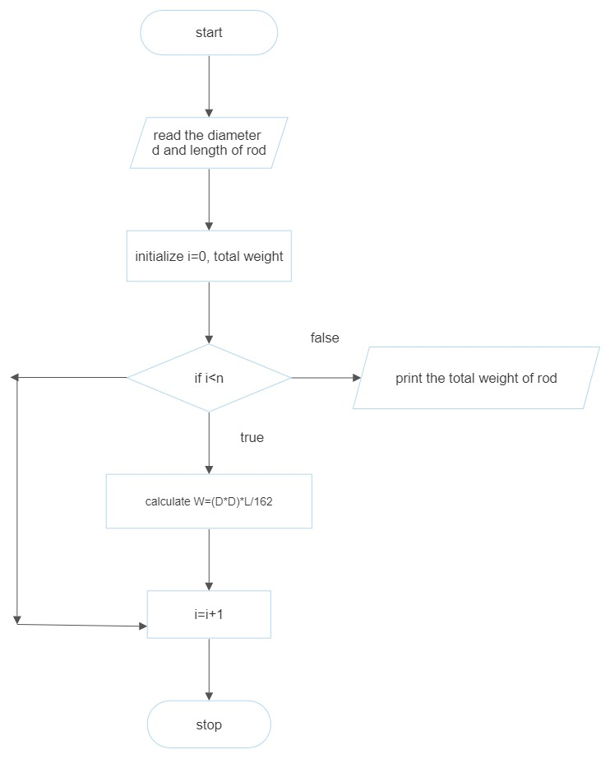

**PSEUDOCODE:**

**START**

**READ** diameter and length

**COMPUTE** i=1 weight=0

IF i<N **THEN**

**CALCULATE** D*162

**ELSE**

**PRINT** TW of the rod

**STOP**

**RESULT:**

Thus the flowchart and algorithm is written for the given program

22CSEB07 **WEIGHT OF THE MOTOR BIKE**

**EXP NO**: 1 - C

**DATE:** 29-11-2022

**AIM:**

To draw the flowchart and algorithm for the given program

**ALGORITHM:**

Step 1: start

Step 2: read the gross vehicle weight rating GVWR

Step 3: read the value of dry weight

Step 4: read the value of fuel weight

Step 5: read the value of rider weight

Step 6: read the value of passenger weight

Step 7: calculate the total weight of the motor bike

Step 8: get the load weight in variable weight

Step 9: calculate the load weight of the vehicle by adding

Step 10: calculate the safe weight by subtracting

Step 11: check the condition if the safe weight is greater than or equal to zero

11.1: if the condition is true, print” you are appreciated for safe journey”

11.2: if the condition is false, print” reduce for the weight for safe journey”

Step 12: stop

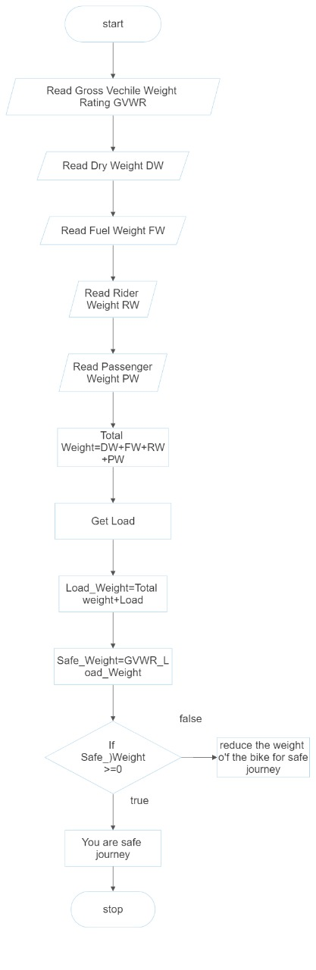

**PSEUDOCODE:**

**START**

**READ** GVWR

**READ** DW, FW, RW, PW

**CALCULATE** total

Weight=DW+FW+RW+PW

**READ** load

**CALCULATE** load _ weight=total

Weight + load

**CALCULATE** safe

Weight = GVWR + load weight

**IF** safe _ weight>=0 **THEN**

**DISPLAY** “You are appreciated for safe journey”

**ELSE**

**DISPLAY** “Reduce for the weight for safe journey”

**STOP**

**RESULT:**

Thus the algorithm and flowchart is written for the given program

22CSEB07

**RETAIL SHOP BILLING**

**EXP NO:** 1 - D

**DATE:** 29-11-2022

**AIM:**

To draw the flowchart and algorithm for the given program

**ALGORITHM:**

Step 1: start

Step 2: read the total number of the items

Step 3: initialize I = 0, total=0

Step 4: check condition I <=n:

4.1: if condition is true, read the product name, no of items, price

4.1.1: calculate total

4.1.2: enter the discount of the items

4.1.3: calculate the discount total

4.1.4: calculate the net total

4.2: if condition is false, read the GST value

4.2.1: calculate the GST amount

4.2.2: calculate the net price

Step 5: print the net price

Step 6 : stop

**FLOWCHART:**

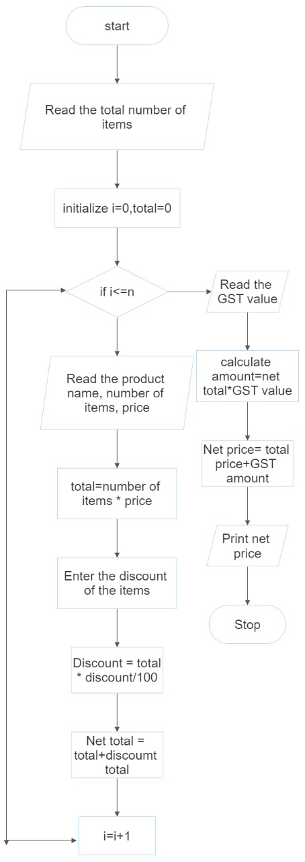

**PSEUDOCODE:**

**START**

**READ** NO OF ITEMS

**INITIALISE** I=0, total=0

**IF** I<=n **THEN**

**READ** product name, no of items and price

**CALCULATE** total

**ENTER** the discount of the items

**CALCULATE** the discount total

**CALCULATE** the net total

**ELSE**

**READ** the GST value

**CALCULATE** the GST amount

**CALCULATE** the net price

**DISPLAY** the net price

**STOP**

**RESULT:**

Thus the algorithm and flowchart written for the given program

22CSEB07

**COMPUTING ELECTRICAL CURRENT IN 3 PHASE AC CIRCUIT**

**EXP NO:** 1 - E

**DATE:** 29-11-2022

**AIM:**

To draw the flowchart and write the algorithm for the given program

**ALGORITHM:**

Step 1: start

Step 2: read voltage, resistance, current, power factor

Step 3: calculate the electric current

Step 4: print electric current

Step 5: stop

**FLOWCHART:**

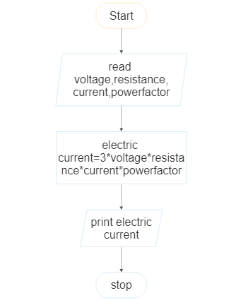

**PSEUDOCODE:**

**START**

**READ** voltage, resistance, current, power factor

**CALCULATE** electric current

**PRINT** electric current

**STOP**

**RESULT:**

Thus the flowchart and algorithm written for the given program

22CSEB07

**STUDENT GRADE ANALYSIS**

**EXP NO:** 1 - F

**DATE:** 29-11-2022

**AIM:**

To draw the algorithm and flowchart for the given program

**ALGORITHM:**

Step 1: start

Step 2: read the marks m1, m2, m3

Step 3: calculate the total

Step 4: calculate the average

Step 5: check for condition average > 30 and average<50

5.1: if condition is true

5.2: print“ your grade is C”

Step 6: check for condition average>50 and average<70

6.1: if condition is true

6.2: print” your grade is B”

Step 7: check for condition average>70 and average<100

7.1: if condition is true

7.2: print” your grade is A”

Step 8: check for condition average <30

8.1: if condition is true

8.2: print” sorry, you can fail”

Step 9: stop

**FLOWCHART:**

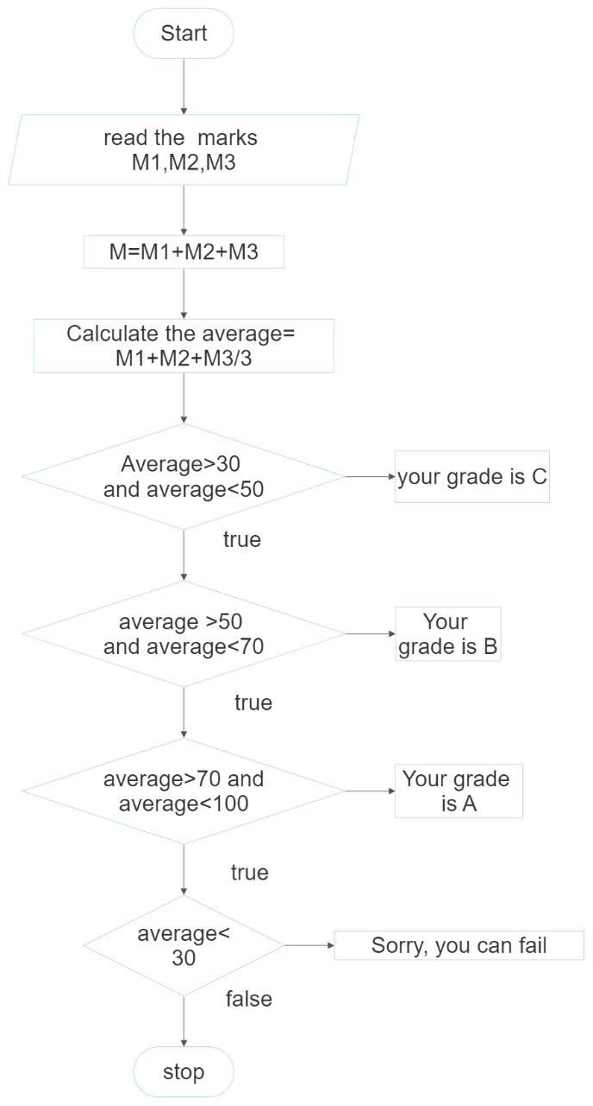

**PSEUDOCODE:**

**START**

**READ** M1+M2+M3

**CALCULATE** total

**CALCULATE** average

**IF** AVG > 30 and AVG< 50

**DISPLAY** “Your grade is C”

**IF** AVG>50 and AVG<70

**DISPLAY** “Your grade is B”

**IF** AVG>70 and AVG<100

**DISPLAY** “Your grade is A”

**IF** AVG<30

**DISPLAY** “Sorry, you can fail”

**STOP**

**RESULT:**

Thus the algorithm and flowchart is written for given program

22CSEB07

**SINE SERIES**

**EXP NO:** 1 - G

**DATE:** 29-11-2022

**AIM**:

To draw the flowchart and algorithm for the given program

**ALGORITHM:**

Step 1: start

Step 2: read the value of x

Step 3: initialize the value of I = 1, sine=0 and import math

Step 4: read the value of n

Step 5: check the value of I < n:

5.1: if condition is true

5.1.1: Sine+(y**2*i+1))/ math .factorial (2*i+1)*s

5.1.2: increment value of I by 1

5.2: if condition is false

Step 6: print” sine series”

Step 7: stop

**FLOWCHART:**

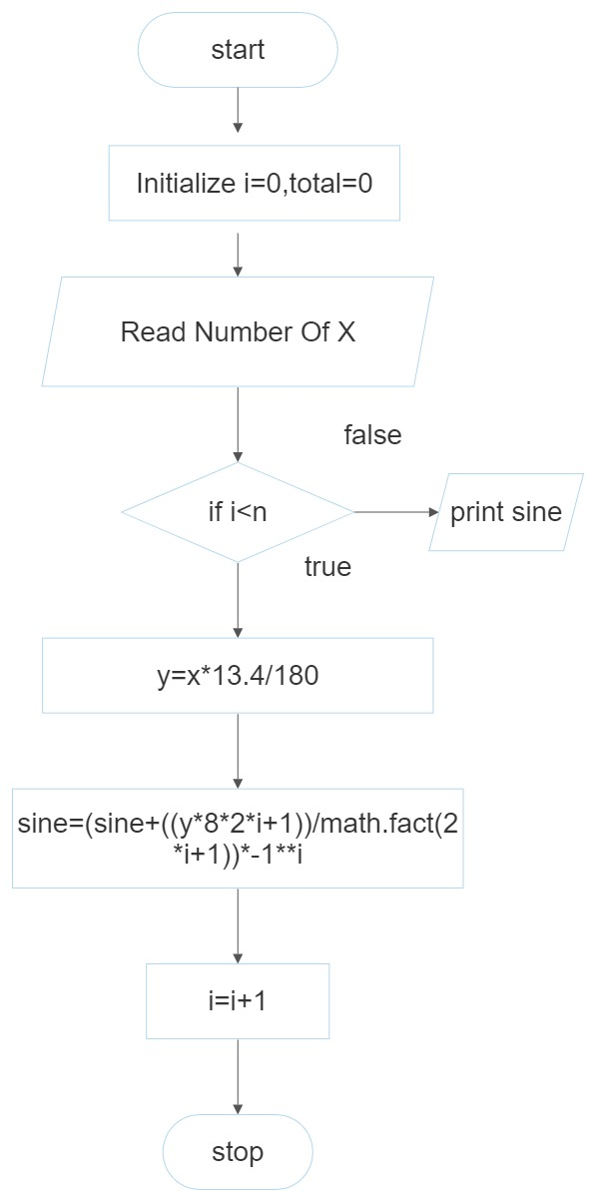

**PSUDOCODE:**

**START**

**READ** X

**INITIALIZE** I=0, total=0

**IF** I<N **THEN**

Y=x*(3.1416/180)

Sine = sine ((y**2*i+1)/ math. factorial(2*i+1))*s

I=i+1

**DISPLAY** SINE

**STOP**

**RESULT:**

Thus the algorithm and flowchart is written for the given program

22CSEB07